 | Howth Yacht Club  OPEN LASER FROSTBITES SERIES  2008 / 2009  Sponsored by Dinghy Supplies  Organised by HYC Events Ltd. | 

You can enter online at www.hyc.ie (easier, quicker, no postage, payment by credit/debit card)

ENTRY FORM

Name ____________________________________________________________________________________

Address ____________________________________________________________________________________

____________________________________________________________________________________

Contact No. __________________________ EMail _________________________________________________

Date of Birth _________________________ Club __________________________________________________

Sail No. _________________________ Rig: Standard Radial 4.7
(Please tick as appropriate)
ENTRY FEES (including Dinghy Park up to END of Series entered)

Both Series | € 155 | HYC Members | € 125 | Junior | € 100
Individual Series | € 90 | HYC Members | € 75 | Junior | € 60

I declare that:
- I agree to be bound by the Racing Rules of Sailing, the prescriptions of the ISA, the Notice of Race, the Sailing Instructions, any amendments thereto and the relevant Class Rules.
- I acknowledge that I enter and sail at my own risk and that neither HYC Events Ltd. nor Howth Yacht Club are liable for any loss or damage to yachts or equipment or injury to persons.
- I am fully aware of the actual and potential risks involved in active water sports, including drowning, hypothermia and other physical injuries. I accept that, by engaging in active water sports, my physical safety and that of my crew could be endangered. I am also aware that other competitors’ actions and the actions or inaction’s of the organisers of water sports events, including the drivers of escort craft, can also endanger my physical safety.
- I have a valid and adequate third party liability marine insurance policy and I further confirm that this policy will remain in full force and effect for the duration of the event.
- I acknowledge that it is up to me personally to assess whether any event or activity on the water is too difficult for me. I acknowledge that the safety of my yacht and its entire management including insurance is my sole responsibility and I am satisfied that the yacht and helm are adequate to face the conditions that may arise in the course of the races.

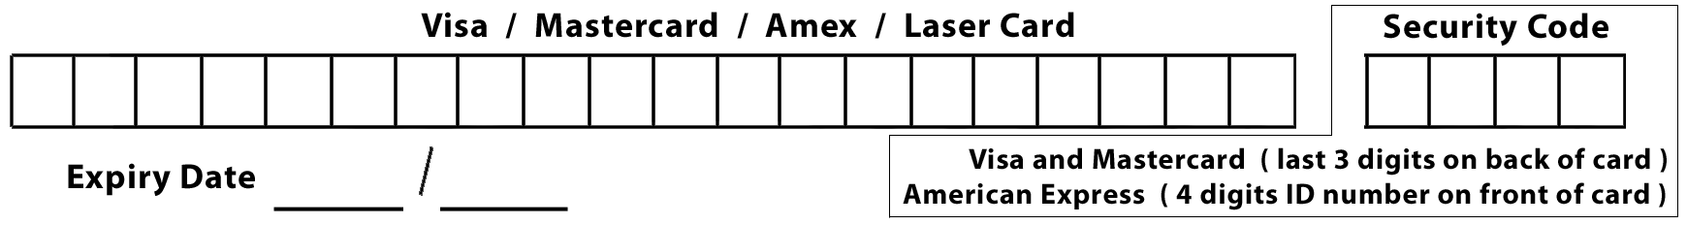

I enclose Laser / Credit Card details / Cheque payable to HYC Events Ltd., for € ________

Signed _________________________________________ Date _______________________
Parent or guardian if under 18 years

Entry form with correct remittance to reach
Secretary, HYC Events Ltd., c/o Howth Yacht Club, Harbour Road, Howth, Co Dublin
before competing in the series.

