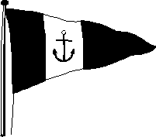 | Howth Yacht Club  DINGHY REGATTA  (Organised by HYC Events Ltd)  Sunday – 12th July 2009

Entry Form

HELM NAME ______________________________________ CLUB _______________ E-MAIL_________________________________

ADDRESS _______________________________________________________________________________________________________

PHONE (H) __________________________ (Mobile) _________________________________________ D.o.B (if u/18) _________________

Crew’s name __________________________________________ Club _________________________ D.o.B (if u/18) _________________

Sail No. | Class | Laser  circle rig type | Optimist  circle one
 |  | 4.7 - Radial - Full | Main Fleet Regatta Fleet

I enclose Laser / Credit Card details / Cash / Cheque, payable to HYC Events Ltd., for the following:

Single handed (e.g. Optimist, Laser ,Topper Uno etc.) |  | € 20.00
Two handed (e.g. 420, Pico,Feva, etc.) |  | €30 .00

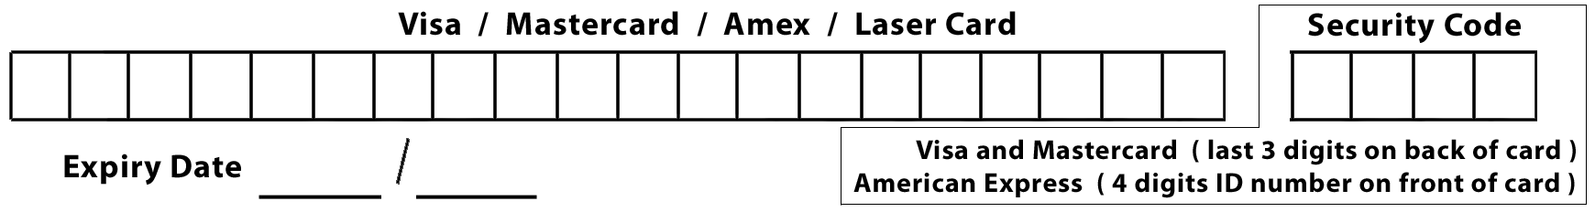

I enclose Laser / Credit Card details / Cheque payable to HYC Events Ltd.
Signature of card holder _________________________________________

DECLARATION
- I agree to be bound by the Racing Rules of Sailing, the prescriptions of the ISA, the Notice of Race, the Sailing Instructions, any amendments thereto and the relevant Class Rules.
- I acknowledge that I enter and sail at my own risk and that neither HYC Events Ltd. nor Howth Yacht Club are liable for any loss or damage to yachts or equipment or injury to persons.
- I agree to waive any claim for loss, damage, or personal injury against Howth Yacht Club, and any individual or body concerned with this event. I agree to indemnify Howth Yacht Club, and any such individual or body concerned against any such claim that may be brought by or on my behalf. I also declare that I hold an adequate & valid Third Party Insurance Policy of not less than €1,250,000 which covers the boat entered whilst taking part in this event.
- I declare that I hold an adequate & valid marine insurance policy with racing inclusion. I further confirm that this policy will remain in full force and effect for the duration of the event. Please note that insurance cover under a house or other policy may not adequately provide for third party liability for damage personal injury or death. If in doubt consult your broker or insurance company.
- I am fully aware of the actual and potential risks involved in active water sports, including drowning, hypothermia and other physical injuries. I accept that, by engaging in active water sports, my physical safety could be endangered. I am also aware that other competitors’ actions and the actions or inaction’s of the organisers of water sports events, including the drivers of escort craft, can also endanger my physical safety.
- I acknowledge that it is up to me personally to assess whether any event or activity on the water is too difficult for me. I acknowledge that the safety of my yacht and its entire management, including insurance, is my sole responsibility and I am satisfied that the yacht and helm are adequate to face the conditions that may arise in the course of the races.
Entrant’s Signature _______________________________ Date __________

For entrants under 18 years of age this form must be counter-signed by a parent or guardian.
As the parent / guardian of sailor I confirm that I have read, understood and agreed to the contents of the above declaration and accept them on behalf of my child/ward
Helm’s name Parent/Guardian (Signature) _______________________________________
(Block Capitals) __________________________ Mobile no. _______________
Crew’s name Parent/Guardian (Signature) _______________________________________
(Block Capitals) __________________________ Mobile no. _______________
Please return to: Secretary, HYC Events Ltd., Harbour Rd., Howth, Co. Dublin
Tel: 832 2141, Fax: 839 2430, E-mail: admin@hyc.ie Web: www.hyc.ie

